Acceptance Test Data Sheets

For

Skyryse Flight OS LEMA TPX 325

|  |  |
| --- | --- |
| LEMA Assembly Part Number | Serial Number |
|  | 12 |

6.1. **Visual Examination of the Product**

|  |  |
| --- | --- |
| UUT conforms to the requirements of paragraph 6.1 | "TDMS.Properties.VISUAL..6\.1\.OK" not found or bad format "%<Failed|True>z" |

6.2 **Weight**

|  |  |
| --- | --- |
| UUT weight should not exceed 10 lbs | actual weight "TDMS.Properties.WEIGHT..6\.1\.Weight" not found or bad format "" lbs |

**6.3 Bonding**

Bonding resistance

|  |  |  |  |  |
| --- | --- | --- | --- | --- |
|  | **Expected** | **Tolerance** | **Simplex** | **Duplex** |
|  | (mOhms) | (mOhms) | (mOhms) | (mOhms) |
| Motor End Cap |  |  |  |  |
| Solenoid housing |  |  |  |  |
| Encoder cover |  |  |  |  |

6.4 Resistance and Inductance Test (motor and solenoid)

**Resistances:**

|  |  |  |  |  |  |
| --- | --- | --- | --- | --- | --- |
|  | **Expected** | **Tolerance** | **Connector J1** | **Connector J2** | **Connector J3** |
| Pins | Resistance (Ohms) | Resistance (Ohms) | Resistance (Ohms) | Resistance (Ohms) | Resistance (Ohms) |
| E to F |  |  |  |  |  |
| F to G |  |  |  |  |  |
| G to E |  |  |  |  |  |
| A to L |  |  |  |  |  |
| G,F,E,A,L tied together to chassis grounds. Apply 500VDC |  |  |  |  |  |

**Inductances:**

|  |  |  |  |  |  |
| --- | --- | --- | --- | --- | --- |
|  | **Expected** | **Tolerance** | **Connector J1** | **Connector J2** | **Connector J3** |
|  |  |  | Inductance(mH) | Inductance(mH) | Inductance(mH) |
| E to F |  |  |  |  |  |
| F to |  |  |  |  |  |
| G to E |  |  |  |  |  |
| A to L |  |  |  |  |  |

6.5 **Power ON UUT Checks**

Confirm all sensors are reporting nominal values and no faults reported

|  |  |  |
| --- | --- | --- |
| Sensor | Value | Pass/Fail |
| Motor 1 | 0 | Pass |
| Motor 2 | -0 | Pass |
| Motor 3 | -0 | Pass |
| M1 | -77 | Failed |
| M2 | -93 | Failed |
| M3 | -104 | Failed |
| Faults 1 | 1024 | Pass |
| Faults 2 | 1024 | Pass |
| Faults 3 | 1024 | Pass |

6.7 **Functional Check Out**

6.7.1 **MCE1, MCE 2, MCE3 Power Up**

|  |  |  |  |
| --- | --- | --- | --- |
| Description | Ballnut position | Pass/Fail | |
| MCE 1 reports values for Ballnut position and motor current | 0 | Ballnut Position | Current |
| Pass | Unhandled Type: Void |
| (Simulated) FCC/reports values for M1(QPS) | -77 | Failed | Unhandled Type: Void |
| MCE 2 reports values for Ballnut position and motor current | 0 | Pass | Unhandled Type: Void |
| (Simulated) FCC/reports values for M2(QPS) | -93 | Failed | Unhandled Type: Void |
| MCE 3 reports values for Ballnut position and motor current | 0.0013 | Pass | Unhandled Type: Void |
| (Simulated) FCC/reports values for M3(QPS) | -104 | Failed | Unhandled Type: Void |

6.7.2 **N1 and N2 Extend Mechanical Stops and MCE Rigging**

**Step 6.7.2.1** **Extend using M1/N1**

|  |  |  |
| --- | --- | --- |
| Description | Value | Pass/Fail |
| N1 extend stop engaged (M1 current saturated) | 1024 | Pass |
| MCE 1 Motor Current 4.5 +/- 0.15 Amps | 6.016 Amps | Failed |
| Linear Encoder Value | 0.1007 | Pass |
| N1 is Rigged | 0 | Pass |

**Step 6.7.2.2** **Extend using M2/N2**

|  |  |  |
| --- | --- | --- |
| Description | Value | Pass/Fail |
| N2 extend stop engaged (M2 current saturated) | 1024 | Pass |
| MCE2 Motor Current 4.5 +/- 0.15 Amps | 5.9732 Amps | Failed |
| Linear Encoder Value | 0.0496 | Pass |
| N2 (Motor 2) is Rigged | 0 | Pass |
| N2 (Motor 3) is Rigged | 0 | Pass |

6.7.3 **N1 and N2 Stroke Check**

|  |  |  |
| --- | --- | --- |
| Pin to pin Length is 16.732 +/- TBD (ins) | Pin to Pin Length | Pass/Fail |
|  |  |
| Description | Actual Position N1/N2 | Pass/Fail |
| N2 at -0.575 ins from Null using M2 | -0.575 | Pass |
| N1 at +1.725 ins from Null using M1 | 1.725 | Pass |
| N1 at -0.575 ins from Null using M1 | -0.575 | Pass |
| N2 at +1.725 ins from NULL using M2 | 1.7247 | Pass |
| N1 at -0.575 ins from Null using M1 | -0.575 | Pass |
| N2 at +1.725 ins from Null using M3 | 1.7246 | Pass |
| N2 at -0.575 ins from Null using M3 | -0.5731 | Pass |

MOTOR 1

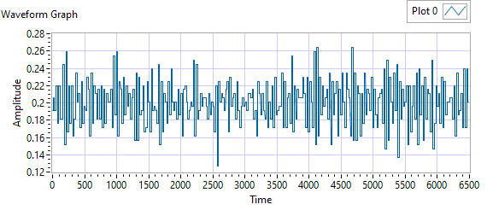

Figure - Ballnut Velocity for Motor One

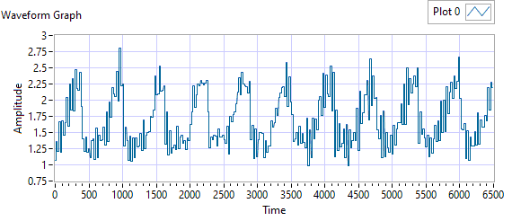

Figure -Current for Motor One

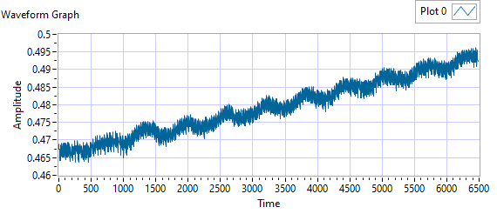

Figure - M1 Delta for Motor One

|  |  |  |  |  |  |
| --- | --- | --- | --- | --- | --- |
| **Description** | **Expected** | **Tolerance** | **Actual Average** | **Peak Velocity** | **Pass/Fail** |
| Constant Velocity | 0.2 | 0.02 | 0.2001 | 0.2643 | Failed |
| **Description** | **Expected** | **Tolerance** | **Actual** | **Standard Deviation** | **Pass/Fail** |
| Delta between Motor 1 Position and M1 position | 0.1 | 0.2 | 78.5965 | 0.0081 | Failed |
| Delta between Motor 1 Position and Linear Encoder position | 0.1 | 0.2 | 0.4963 | 0.3746 | Failed |
| Motor Current |  |  | 1.6937 | 0.4078 |  |

|  |  |  |  |  |
| --- | --- | --- | --- | --- |
| Description | Expected Difference from Test rig encoder | Tolerance | Difference from Test rig encoder | Pass/Fail |
| Motor 1 position + Motor 2 position = test rig encoder | 0 | 0.1 | -0.0957 | Pass |
| Motor1 position + Motor 3 position = test rig encoder | 0 | 0.1 | -0.0957 | Pass |
| M1 position + M2 position = test rig encoder | 0.1 | 0.1 | -170.4704 | Failed |
| M1 position + M3 position = test rig encoder | 0 | 0.1 | -181.4704 | Failed |
| Difference between Motor 2 position and Motor 3 position is < TBD ins | 0 | 0.1 | 0 | Pass |
| Difference between M2 position and M3 position is < TBD ins | 0 | 0 | 11 | Failed |
| Difference between Motor 1 position and M1 position is < TBD ins | 0 | 0.1 | 77.9497 | Failed |
| Difference between Motor 2 position and M2 position is < TBD ins | 0 | 0.1 | 92.425 | Failed |
| Difference between Motor 3 position and M3 position is < TBD ins | 0 | 0.1 | 103.425 | Failed |

MOTOR 2

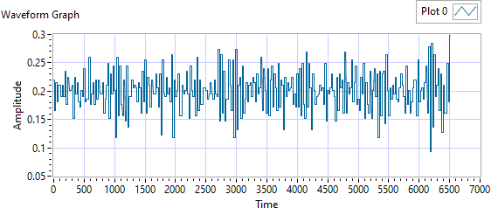

Figure - Ballnut Velocity for Motor Two

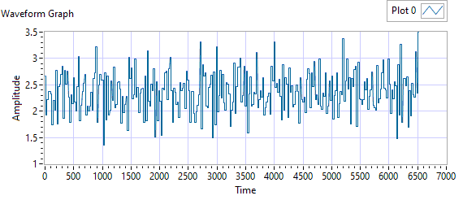

Figure -Current for Motor Two

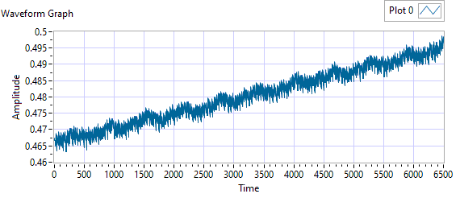

Figure - M1 Delta for Motor Two

|  |  |  |  |  |  |
| --- | --- | --- | --- | --- | --- |
| **Description** | **Expected** | **Tolerance** | **Actual Average** | **Peak Velocity** | **Pass/Fail** |
| Constant Velocity | 0.2 | 0.02 | 0.2002 | 0.2986 | Failed |
| **Description** | **Expected** | **Tolerance** | **Actual** | **Standard Deviation** | **Pass/Fail** |
| Delta between Motor 2 Position and M2 position | 0.1 | 0.2 | 94.5989 | 0.0085 | Failed |
| Delta between Motor 2 Position and Linear Encoder position | 0.1 | 0.2 | 0.499 | 0.3763 | Failed |
| Motor Current |  |  | 2.3623 | 0.3794 |  |

|  |  |  |  |  |
| --- | --- | --- | --- | --- |
| Description | Expected Difference from Test rig encoder | Tolerance | Difference from Test rig encoder | Pass/Fail |
| Motor 1 position + Motor 2 position = test rig encoder | 0 | 0.1 | -0.0948 | Pass |
| Motor1 position + Motor 3 position = test rig encoder | 0 | 0.1 | -0.0947 | Pass |
| M1 position + M2 position = test rig encoder | 0.1 | 0.1 | -170.4568 | Failed |
| M1 position + M3 position = test rig encoder | 0 | 0.1 | -181.4568 | Failed |
| Difference between Motor 2 position and Motor 3 position is < TBD ins | 0 | 0.1 | 0.0012 | Pass |
| Difference between M2 position and M3 position is < TBD ins | 0 | 0 | 11 | Failed |
| Difference between Motor 1 position and M1 position is < TBD ins | 0 | 0.1 | 76.425 | Failed |
| Difference between Motor 2 position and M2 position is < TBD ins | 0 | 0.1 | 93.937 | Failed |
| Difference between Motor 3 position and M3 position is < TBD ins | 0 | 0.1 | 104.9371 | Failed |

MOTOR 3

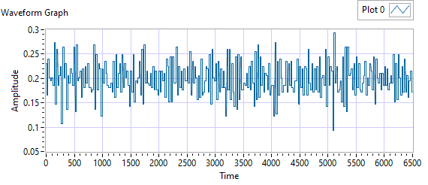

Figure - Ballnut Velocity for Motor Three

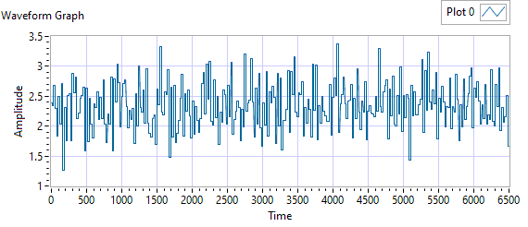

Figure -Current for Motor Three



Figure - M3 Delta for Motor Three

|  |  |  |  |  |  |
| --- | --- | --- | --- | --- | --- |
| **Description** | **Expected** | **Tolerance** | **Actual Average** | **Peak Velocity** | **Pass/Fail** |
| Constant Velocity | 0.2 | 0.02 | 0.1999 | 0.2937 | Failed |
| **Description** | **Expected** | **Tolerance** | **Actual** | **Standard Deviation** | **Pass/Fail** |
| Delta between Motor 3 Position and M3 position | 0.1 | 0.2 | 105.5877 | 0.0085 | Failed |
| Delta between Motor 3 Position and Linear Encoder position | 0.1 | 0.2 | 0.4988 | 0.3753 | Failed |
| Motor Current |  |  | 2.3445 | 0.3872 |  |

|  |  |  |  |  |
| --- | --- | --- | --- | --- |
| Description | Expected Difference from Test rig encoder | Tolerance | Difference from Test rig encoder | Pass/Fail |
| Motor 1 position + Motor 2 position = test rig encoder | 0 | 0.1 | -0.0947 | Pass |
| Motor1 position + Motor 3 position = test rig encoder | 0 | 0.1 | -0.0946 | Pass |
| M1 position + M2 position = test rig encoder | 0.1 | 0.1 | -170.4697 | Failed |
| M1 position + M3 position = test rig encoder | 0 | 0.1 | -181.4697 | Failed |
| Difference between Motor 2 position and Motor 3 position is < TBD ins | 0 | 0.1 | 0.0012 | Pass |
| Difference between M2 position and M3 position is < TBD ins | 0 | 0 | 11 | Failed |
| Difference between Motor 1 position and M1 position is < TBD ins | 0 | 0.1 | 76.425 | Failed |
| Difference between Motor 2 position and M2 position is < TBD ins | 0 | 0.1 | 93.9501 | Failed |
| Difference between Motor 3 position and M3 position is < TBD ins | 0 | 0.1 | 104.9501 | Failed |

**6.7.4 Brake Release Test**

**Step d –** LEMA reaches commanded position

|  |  |  |  |  |
| --- | --- | --- | --- | --- |
| Description | Expected | Tolerance | Position | Pass/Fail |
| MCE1 /Motor 1 | 0.2 |  | 0.1872 | Pass |
| MCE2 /Motor 2 | 0.2 |  | 0.1838 | Pass |
| MCE3 /Motor 3 | 0.2 |  | 0.1863 | Pass |

**6.7.5 Performance Test – unloaded operation (one channel operation)**

**6.7.5.1.1 MCE 1 - Step Response Test**

**The result for motor one is shown below:**

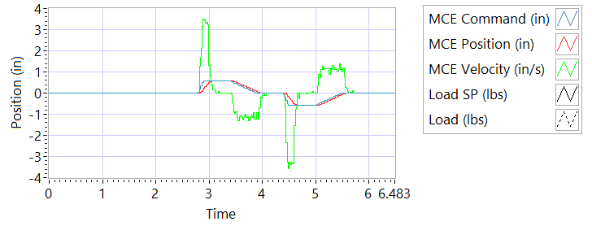

Figure - Results for Motor One

**Step d Extension**

|  |  |  |
| --- | --- | --- |
| Description | Actual Speed / Time | Pass/Fail |
| No Load speed is 2.7 to 3.3 in/sec | 3.0148 | True |
| Time to achieve 80% of the specified stroke (+ 0.575 ins) is 170+9/-9 ms seconds | 200 | Failed |

**Step e Retraction**

|  |  |  |
| --- | --- | --- |
| Description | Actual Speed / Time | Pass/Fail |
| No Load speed is 2.7 to 3.3 in/sec | -3.0987 | Failed |
| Time to achieve 80% of the specified stroke (- 0.575 ins) is 170+9/-9 ms seconds | 194 | Failed |

**6.7.5.1.2 MCE 1 - Frequency Response**

**Step d**

**Frequency Response**

|  |  |  |  |
| --- | --- | --- | --- |
| **Frequency** | **Phase** | **Max phase** | **Pass/Fail** |
| 0.1 Hz | -2.5848 | -5 |  |
| 0.5 Hz | -13.23 | -10 |  |
| 1 Hz | -26.928 | -20 |  |
| 2 Hz | -50.544 | -30 |  |
| 3 Hz | -73.116 | -50 |  |
| 4 Hz | -93.456 | -60 |  |
| 5 Hz | -114.48 | -70 |  |

6.7.5.2.1 **MCE 2 - Step Response Test**

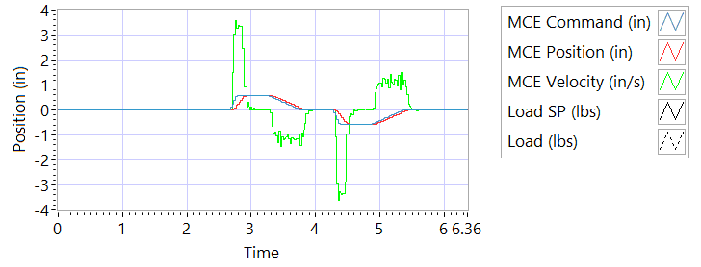

Figure - Results for Motor Two

**Step d Extension**

|  |  |  |
| --- | --- | --- |
| Description | Actual Speed / Time | Pass/Fail |
| No Load speed is 2.7 to 3.3 in/sec | 3.2447 | True |
| Time to achieve 80% of the specified stroke (+ 0.575 ins) is 170+9/-9 ms seconds | 174 | True |

**Step e Retraction**

|  |  |  |
| --- | --- | --- |
| Description | Actual Speed / Time | Pass/Fail |
| No Load speed is 2.7 to 3.3 in/sec | -3.2977 | Failed |
| Time to achieve 80% of the specified stroke (- 0.575 ins) is 170+9/-9 ms seconds | 190 | Failed |

6.7.5.2.2 **MCE 2 - Frequency Response Test**

**Step d**

**Frequency Response**

|  |  |  |  |
| --- | --- | --- | --- |
| **Frequency** | **Phase** | **Max phase** | **Pass/Fail** |
| 0.1 Hz | -2.2572 | -5 |  |
| 0.5 Hz | -13.824 | -10 |  |
| 1 Hz | -26.784 | -20 |  |
| 2 Hz | -51.192 | -30 |  |
| 3 Hz | -72.792 | -50 |  |
| 4 Hz | -92.88 | -60 |  |
| 5 Hz | -108 | -70 |  |

6.7.5.3.1 **MCE 3 – Step Response Test**



Figure - Results for Motor Three

**Step d Extension**

|  |  |  |
| --- | --- | --- |
| Description | Actual Speed / Time | Pass/Fail |
| No Load speed is 2.7 to 3.3 in/sec | 3.0623 | True |
| Time to achieve 80% of the specified stroke (+ 0.575 ins) is 170+9/-9 ms seconds | 193 | Failed |

**Step e Retraction**

|  |  |  |
| --- | --- | --- |
| Description | Actual Speed / Time | Pass/Fail |
| No Load speed is 2.7 to 3.3 in/sec | -3.128 | Failed |
| Time to achieve 80% of the specified stroke (+ 0.575 ins) is 170+9/-9 ms seconds | 190 | Failed |

6.7.5.3.2 **MCE 3 Frequency Response Test**

**Step d**

|  |  |  |  |
| --- | --- | --- | --- |
| **Frequency** | **Phase** | **Max phase** | **Pass/Fail** |
| 0.1 Hz | -2.1888 | -5 |  |
| 0.5 Hz | -12.816 | -10 |  |
| 1 Hz | -26.46 | -20 |  |
| 2 Hz | -50.688 | -30 |  |
| 3 Hz | -72.036 | -50 |  |
| 4 Hz | -92.736 | -60 |  |
| 5 Hz | -110.52 | -70 |  |

6.7.6 **Performance Test – Loaded Operation**

6.7.6.1 **Step and Frequency Response Test - Loaded**

6.7.6.1.1 **MCE1 – Step Response Test**

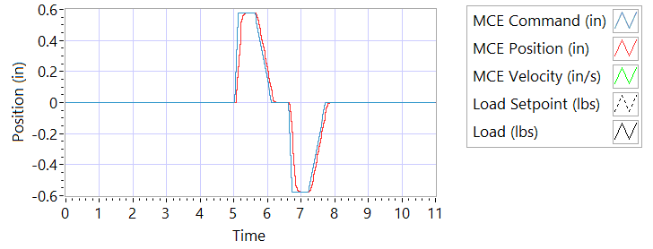

Figure - Results for Motor One Loaded

Step response Test

**Step j – 225 lbf tension**

|  |  |  |
| --- | --- | --- |
| Description | Actual Value | Pass/Fail |
| speed between 2.07 and 2.53 in/sec | 3.2058 | True |
| Time to achieve 80% of the specified stroke (+ 0.575 ins) is 170 +9/-9 ms | 192 | Failed |

**Step k – 225 lbf tension**

|  |  |  |
| --- | --- | --- |
| Description | Actual Value | Pass/Fail |
| speed between 2.07 and 2.53 in/sec | -2.9882 | Failed |
| Time to achieve 80% of the specified stroke (- 0.575 ins) is 170 +9/-9 ms | 189 | Failed |

**Step n – 225 lbf compression**

|  |  |  |
| --- | --- | --- |
| Description | Actual Value | Pass/Fail |
| speed between 2.07 and 2.53 in/sec | 2.8646 | True |
| Time to achieve 80% of the specified stroke (+ 0.575 ins) is 170 +9/-9 ms | 187 | Failed |

**Step o – 225 lbf compression**

|  |  |  |
| --- | --- | --- |
| Description | Actual Value | Pass/Fail |
| speed between 2.07 and 2.53 in/sec | -0 | Failed |
| Time to achieve 80% of the specified stroke (- 0.575 ins) is 170 +9/-9 ms | 4177 | Failed |

6.7.6.1.2 **MCE 1 – Frequency Response Test**

**Step d – 225 lbf Tension**

|  |  |  |  |
| --- | --- | --- | --- |
| **Frequency** | **Phase** | **Max phase** | **Pass/Fail** |
| 0.1 HZ | -7.2 | -5 |  |
| 0.5 HZ | -840.276 | -10 |  |
| 1 HZ | -393.768 | -20 |  |
| 2 HZ | -465.84 | -30 |  |
| 3 HZ | -457.488 | -50 |  |
| 4 HZ | -502.848 | -60 |  |
| 5 HZ | -561.42 | -70 |  |

**Step h – 225 lbf Compression**

|  |  |  |  |
| --- | --- | --- | --- |
| **Frequency** | **Phase** | **Max phase** | **Pass/Fail** |
| 0.1 HZ | -7.2 | -5 |  |
| 0.5 HZ | -840.276 | -10 |  |
| 1 HZ | -393.768 | -20 |  |
| 2 HZ | -465.84 | -30 |  |
| 3 HZ | -457.488 | -50 |  |
| 4 HZ | -502.848 | -60 |  |
| 5 HZ | -561.42 | -70 |  |

6.7.6.1.3 **MCE 2 – Step Response Test**

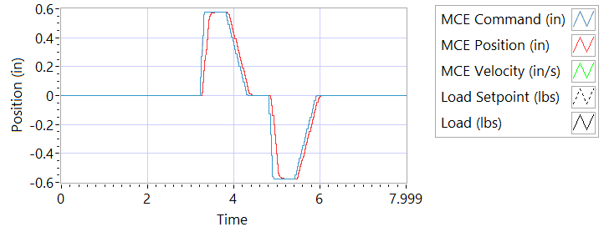

Figure - Results for Motor Two Loaded

**Step j – 225 lbf tension**

|  |  |  |
| --- | --- | --- |
| Description | Actual Value | Pass/Fail |
| speed between 2.07 and 2.53 in/sec | 3.3216 | Failed |
| Time to achieve 80% of the specified stroke (+ 0.575 ins) is 170 +9/-9 ms | 184 | Failed |

**Step k – 225 lbf tension**

|  |  |  |
| --- | --- | --- |
| Description | Actual Value | Pass/Fail |
| speed between 2.07 and 2.53 in/sec | -2.9556 | Failed |
| Time to achieve 80% of the specified stroke (- 0.575 ins) is 170 +9/-9 ms | 181 | Failed |

**Step n – 225 lbf compression**

|  |  |  |
| --- | --- | --- |
| Description | Actual Value | Pass/Fail |
| speed between 2.07 and 2.53 in/sec | 2.9824 | True |
| Time to achieve 80% of the specified stroke (+ 0.575 ins) is 170 +9/-9 ms | 189 | Failed |

**Step o – 225 lbf compression**

|  |  |  |
| --- | --- | --- |
| Description | Actual Value | Pass/Fail |
| speed between 2.07 and 2.53 in/sec | -3.272 | Failed |
| Time to achieve 80% of the specified stroke (- 0.575 ins) is 170 +9/-9 ms | 185 | Failed |

6.7.6.1.4 **MCE 2 – Frequency response Test**

**Step d – 225 lbf Tension**

|  |  |  |  |
| --- | --- | --- | --- |
| **Frequency** | **Phase** | **Max phase** | **Pass/Fail** |
| 0.1 HZ | -2.88 | -5 |  |
| 0.5 HZ | -11.7 | -10 |  |
| 1 HZ | -25.956 | -20 |  |
| 2 HZ | -49.104 | -30 |  |
| 3 HZ | -70.2 | -50 |  |
| 4 HZ | -91.44 | -60 |  |
| 5 HZ | -111.78 | -70 |  |

**Step h – 225 lbf Compression**

|  |  |  |  |
| --- | --- | --- | --- |
| **Frequency** | **Phase** | **Max phase** | **Pass/Fail** |
| 0.1 HZ | -7.2 | -5 |  |
| 0.5 HZ | -33.75 | -10 |  |
| 1 HZ | -36.252 | -20 |  |
| 2 HZ | -62.496 | -30 |  |
| 3 HZ | -82.188 | -50 |  |
| 4 HZ | -104.976 | -60 |  |
| 5 HZ | -126 | -70 |  |

6.7.6.1.5 **MCE 3 – Step Response Test**



Figure - Results for Motor Three

**Step j – 225 lbf tension**

|  |  |  |
| --- | --- | --- |
| Description | Actual Value | Pass/Fail |
| speed between 2.07 and 2.53 in/sec | 3.2359 | True |
| Time to achieve 80% of the specified stroke (+ 0.575 ins) is 170 +9/-9 ms | 171 | True |

**Step k – 225 lbf tension**

|  |  |  |
| --- | --- | --- |
| Description | Actual Value | Pass/Fail |
| speed between 2.07 and 2.53 in/sec | -2.8473 | Failed |
| Time to achieve 80% of the specified stroke (- 0.575 ins) is 170 +9/-9 ms | 190 | Failed |

**Step n – 225 lbf compression**

|  |  |  |
| --- | --- | --- |
| Description | Actual Value | Pass/Fail |
| speed between 2.07 and 2.53 in/sec | 2.8735 | True |
| Time to achieve 80% of the specified stroke (+ 0.575 ins) is 170 +9/-9 ms | 188 | Failed |

**Step o – 225 lbf compression**

|  |  |  |
| --- | --- | --- |
| Description | Actual Value | Pass/Fail |
| speed between 2.07 and 2.53 in/sec | -3.3441 | Failed |
| Time to achieve 80% of the specified stroke (- 0.575 ins) is 170 +9/-9 ms | 184 |  |

6.7.6.1.6 **MCE 3 – Frequency Response Test**

**Step d – 225 lbf Tension**

|  |  |  |  |
| --- | --- | --- | --- |
| **Frequency** | **Phase** | **Max phase** | **Pass/Fail** |
| 0.1 HZ | -2.88 | -5 |  |
| 0.5 HZ | -9.234 | -10 |  |
| 1 HZ | -24.264 | -20 |  |
| 2 HZ | -47.88 | -30 |  |
| 3 HZ | -69.66 | -50 |  |
| 4 HZ | -93.888 | -60 |  |
| 5 HZ | -112.5 | -70 |  |

**Step h – 225 lbf Compression**

|  |  |  |  |
| --- | --- | --- | --- |
| **Frequency** | **Phase** | **Max phase** | **Pass/Fail** |
| 0.1 HZ | -7.2 | -5 |  |
| 0.5 HZ | -33.84 | -10 |  |
| 1 HZ | -36 | -20 |  |
| 2 HZ | -62.136 | -30 |  |
| 3 HZ | -81.864 | -50 |  |
| 4 HZ | -105.696 | -60 |  |
| 5 HZ | -128.34 | -70 |  |

**6.7.7 Holding Load Test**

6.7.7.1 Brake OFF, LEMA Output Locked

|  |  |  |  |  |
| --- | --- | --- | --- | --- |
| MCE | Expected Output force, lbf | Actual Output force, lbf | Output force, Pass/Fail | Position feedback signals (all sensors) Pass/Fail |
| MCE 1, 6.7.8.1.1 step i – extend 0.2 in |  | FORCE | Failed | RESULTS |
| MCE 1, 6.7.8.1.1 step k - retract 0.2 in |  | 952.0436 | Failed | RESULTS |
| MCE 2, m step i – extend 0.2 in |  | -1016.9932 | Failed | RESULTS |
| MCE 2, m step k - retract 0.2 in |  | 912.619 | Failed | RESULTS |
| MCE 3 m step i – extend 0.2 in |  | -1023.8706 | Failed | RESULTS |
| MCE 3 m step k - retract 0.2 in |  | 930.2379 | Failed | RESULTS |

**6.7.7.2 Brake ON, LEMA Output Free**

|  |  |  |  |  |
| --- | --- | --- | --- | --- |
| MCE | 12.6 +- TBD Amps for 3-5 sec | Current Pass/Fail | Position feedback | Position Feedback Pass/Fail |
| MCE 1, 6.7.8.2.1 step I – extend 0.2 in | 20.0035 | True | -0.0976 | Failed |
| MCE 1, 6.7.8.2.1 step k - retract 0.2 in | -19.993 | Failed | -0.0984 | Failed |
| MCE 2, 6.7.8.2.2 6.7.8.2.3 step i – extend 0.2 in | 20.0025 | True | -0.1157 | Failed |
| MCE 2, m step k - retract 0.2 in | 20.001 | Failed | -0.1157 | Failed |
| MCE 3 m step i– extend 0.2 in | 20.0035 | True | -0.015 | Failed |
| MCE 3 m step k - retract 0.2 in | -20.0037 | True | -0.0189 | Failed |

**6.7.7.3 Brake Release test**

**Step d –** LEMA reaches commanded position

|  |  |  |  |  |
| --- | --- | --- | --- | --- |
| Description | Expected | Tolerance | Position | Pass/Fail |
| MCE1 /Motor 1 | 0.2 |  | 0.1872 | Pass |
| MCE2 /Motor 2 | 0.2 |  | 0.1838 | Pass |
| MCE3 /Motor 3 | 0.2 |  | 0.1863 | Pass |

6.7.8 **Backlash**

6.7.8.1 **Simplex Brake 1 – ON; Duplex brake 2 – OFF**

|  |  |  |
| --- | --- | --- |
| Load (lbf) | Backlash (ins) | Pass/Fail |
| Step e +/- 100 lbf (motor 2 and motor 3 ZERO position) | INCHES | RESULTS |
| Step h, Total backlash | INCHES | RESULTS |
| Step f 322 lbf tension followed by 322 lbf compression | INCHES | RESULTS |
| All channels feedback signals (Motor 1, Motor 2, Motor 3, M1, M2 and M3 remain within allowable limits | INCHES | RESULTS |

6.7.8.2 **Simplex Brake 1 – OFF; Duplex Brake 2 – ON**

|  |  |  |
| --- | --- | --- |
| Load (lbf) | Backlash (ins) | Pass/Fail |
| Step e +/- 100 lbf (motor 1 holding ZERO position) | INCHES | RESULTS |
| Step h, Total backlash | INCHES | RESULTS |
| Step f, 322 lbf tension followed by 322 lbf compression | INCHES | RESULTS |
| All channels feedback signals (Motor 1, Motor 2, Motor 3, M1, M2 and M3 remain within allowable limits | INCHES | RESULTS |

6.7.8.3 **Both Brakes OFF**

|  |  |  |
| --- | --- | --- |
| Load (lbf) | Backlash (ins) | Pass/Fail |
| Step e +/- 100 lbf (both motors holding ZERO position) | INCHES | RESULTS |
| Step h, Total backlash | INCHES | RESULTS |
| Step f 322 lbf tension followed by 322 lbf compression | INCHES | RESULTS |
| All channels feedback signals (Motor 1, Motor 2, Motor 3, M1, M2 and M3 remain within allowable limits | INCHES | RESULTS |